**Web Data Connectors**

Create a Web Data Connector (WDC) when you want to connect to a web data source from Tableau. A WDC is an HTML page with JavaScript code that connects to web data (for example, by means of a REST API), converts the data to a JSON format, and passes the data to Tableau.

#### Web Data Connector

With the Web Data Connector SDK, you can unlock a world of data that's available over the web. In addition to using the dozens of data connectors that are already available in Tableau, you can now create your own web data connector (WDC) that reads data from virtually any site that publishes data in JSON, XML, or HTML.

Every web data connector must include a reference to the Tableau WDC library. You can get the latest version of the WDC here:

* <https://connectors.tableau.com/libs/tableauwdc-2.3.latest.js>

There is also a minified version available:

* <https://connectors.tableau.com/libs/tableauwdc-2.3.latest.min.js>

Compatibility with versions of Tableau:

The following table displays which versions of the WDC are compatible with Tableau Desktop:

| **WDC version** | **Tableau version** |
| --- | --- |
| tableauwdc-2.3.0 | 10.4 or later |
| tableauwdc-2.2.0 | 10.2 or later |
| tableauwdc-2.1.0 | 10.1 or later |
| tableauwdc-2.0.2 | 10.0 and later |
| tableauwdc-2.0.0 | 10.0 through 2019.2 |
| tableauwdc-1.1.1 | 9.3 through 2019.2 9.2.4 through 2019.2 9.1.6 through 2019.2 |
| tableauwdc-1.1.0 | 9.2.0 through 9.2.3 9.1.0 through 9.1.5 |

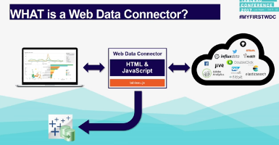

Web Data Connectors now enable you to unlock sources and easily bring your data into Tableau from both internal and external web services.

Requesting data from data sources like https, http, and social networks like that and fetch the data and save it through Web Data Connector API to tableau Extract

If you create your own WDC in tableau server, you must be a Server Administrator to approve for using WDC in tableau server.

WDCs require your approval because they contain executable code and typically make requests to third-party websites. Before a user can use a WDC with

Tableau Server, you must add the domain and port used by the connector to a safe list (whitelist) and also include the domains that a connector can send requests to and receive requests from on a secondary safe list (secondary whitelist). Before you do this, we recommend that you vet and test the connector so that you know what the connector does and what sites it connects to.

## Manage connectors in a safe list

To add a WDC to the safe list, use the tsm data-access web-data-connectors add command. This command and the related commands described below let you perform the following tasks:

* Add WDCs to the safe list and secondary safe list.
* Allow or disallow all WDCs, or WDC refreshes.
* Remove one or more connectors from the safe list.
* List all WDCs on the safe list and secondary safe list.

**To Use WDC for tableau Desktop:**

1. On the start page, in the **Connect** pane, click **More Servers… > Web Data Connector**.

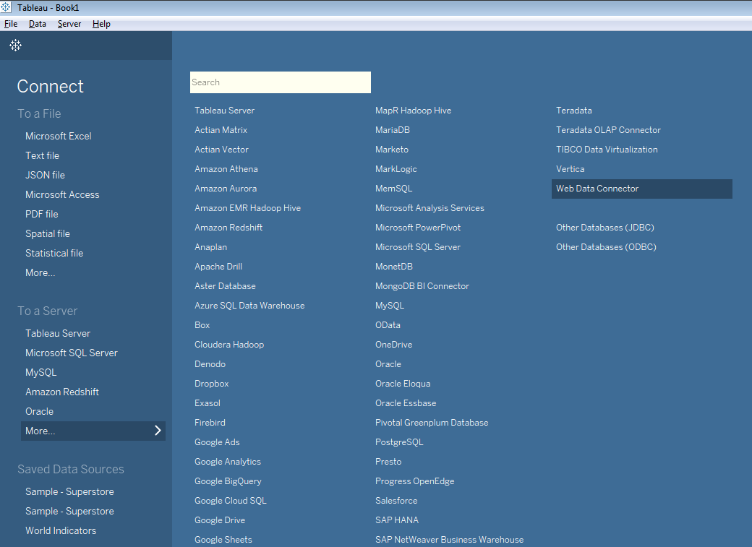

After click on Web Data Connector then it will open one popup like this

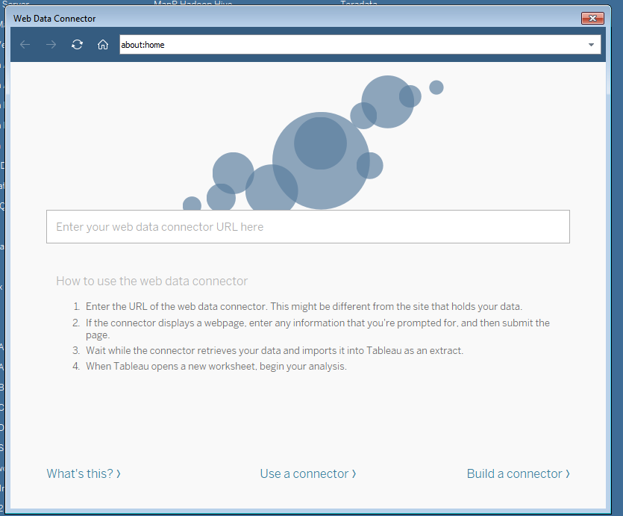

2. Enter the URL of a WDC and press Enter.

1. Make sure that you enter the URL of a WDC, and not the URL of the data that you’re trying to connect to. For example, if you want to connect to FaceBook data, you might
2. Enter [www.example.com/myFacebookWDC.html](http://www.example.com/myFacebookWDC.html).
3. Tableau loads the WDC page where you can enter any input required by your WDC.
4. Tableau calls your WDC code, downloads data, and displays it in the **Data Source** pane.

To build a WDC we need to know the web development kits

* JavaScript
* HTML
* CSS
* How REST APIs work
* Other web programming skills

We need to download the WDC SDK, it contains simulator, developer samples and documentation are all open source.

**The SDK consists of:**

* A simulator for testing your connector.
* Sample connectors.
* The Tableau Web Data Connector Javascript library.
* [Create the HTML page](http://tableau.github.io/webdataconnector/docs/wdc_tutorial#create-the-html-page)
* [Create the connector object](http://tableau.github.io/webdataconnector/docs/wdc_tutorial#create-the-connector-object)
* [Add an event listener](http://tableau.github.io/webdataconnector/docs/wdc_tutorial#add-an-event-listener)
* [Test the connector so far](http://tableau.github.io/webdataconnector/docs/wdc_tutorial#test-the-connector-so-far)
* [Define a schema](http://tableau.github.io/webdataconnector/docs/wdc_tutorial#define-a-schema)
* [Get the data](http://tableau.github.io/webdataconnector/docs/wdc_tutorial#get-the-data)
* [See it in action](http://tableau.github.io/webdataconnector/docs/wdc_tutorial#see-it-in-action)

Here for example,

We need connect for one of the WDC as Splitwise WDC

[https://tableau-wdc-splitwise.herokuapp.com](https://tableau-wdc-splitwise.herokuapp.com/)

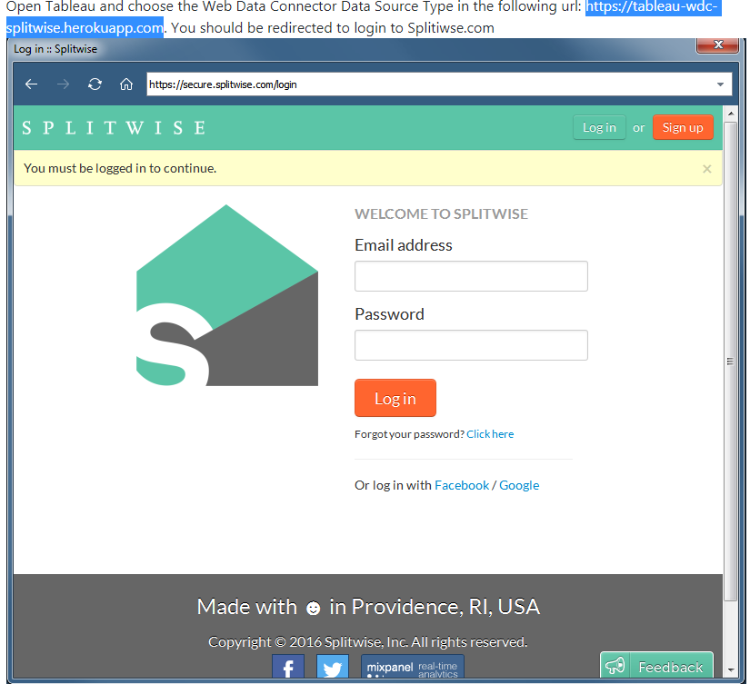

Enter the credentials for email and password

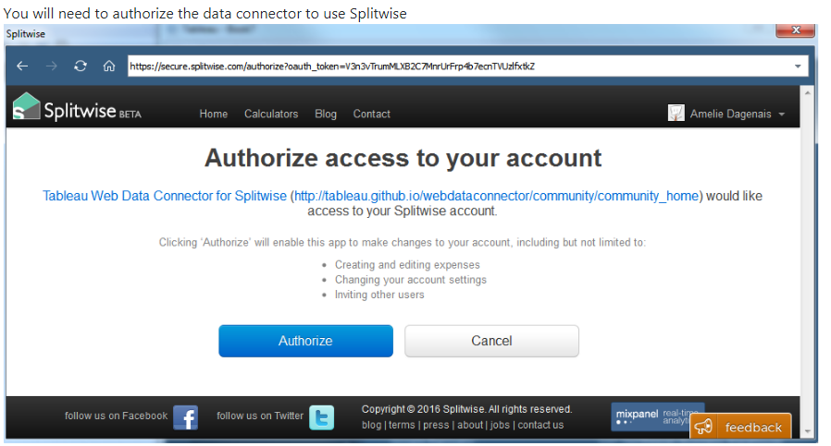

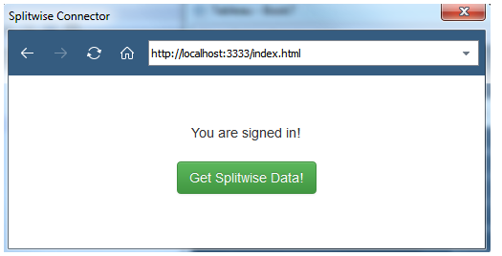

If you click on Get Splitwise Data then automatically you redirected to tableau data after that you will create reports on tableau.